Student Number: 154261
Student Name: Crisleidy Lopez De La Cruz

Crisleidy objectives 6 and 7

Write a short report (1-2 pages) where you discuss your Sustainable Development Goals indicators.
- Describe what SDG target and goal your indicator is monitoring, and how. (1/4 page)
- Why is this SDG target and goal important to Aruba? (1/4 page)
- How does this SDG target and goal relate to waste management in Aruba? (1/4 page)
- Find out if the described indicator is being monitored in Aruba:
  - If so, who collects it? If possible, include a link or reference to the data.
  - If not, describe where you inquired, and what the response was (e.g. CBS).

5. Proportion of urban solid waste regularly collected and with adequate final discharge out of total urban solid waste generated, by cities
6. Annual mean levels of fine particulate matter (e.g. PM2.5 and PM10) in cities (population weighted)
7. Average share of the built-up area of cities that is open space for public use for all, by sex, age and persons with disabilities
8. Proportion of persons victim of physical or sexual harassment, by sex, age, disability status and place of occurrence, in the previous 12 months

- The percentage of urban population is between 60% and 70%
The functional solid urban waste sector has a government agency (central or federal) these agencies have regulatory functions and planning, supervision and control.

- Grouping of Latin American and Caribbean countries according to their total population

Total population  (in millions) | Countries
Less than 0.5 | Antigua and Barbuda, Netherlands Antilles, Bahamas, Barbados, Belize, Dominica, Grenada, Guadeloupe, Saint Kitts and Nevis, Saint Lucia, Saint Vincent and the Grenadines, Suriname
Between 0.5 and 1.0 | Guyana
Between 1.0 and 5.0 | Costa Rica, Jamaica, Nicaragua, Panama,  Paraguay, Trinidad and Tobago, Uruguay
Between 5.0 and 10.0 | Bolivia, El Salvador, Haiti, Honduras, Dominican Republic
Between 10.0 and 20.0 | Chile, Cuba, Ecuador, Guatemala
Between 10.0 and 20.0 | Argentina, Colombia, Peru and Venezuela
Between 10.0 and 20.0 | Mexico
More than 100.0 | Brazil

4. There is no country or community safe from violence. Images and descriptions of violent acts invade the media. It is on our streets and in our homes, in schools, workplaces and other centers. It is a ubiquitous scourge that tears apart the community fabric and threatens the life, health and happiness of all of us. Each year, more than 1.6 million people around the world lose their lives violently. For every person who dies from violent causes, many more are injured and suffer a variety of physical, sexual, reproductive and mental problems. Violence is one of the main causes of death in the population aged between 15 and 44 years, and responsible for 14% of deaths in the male population and 7% in the female population.

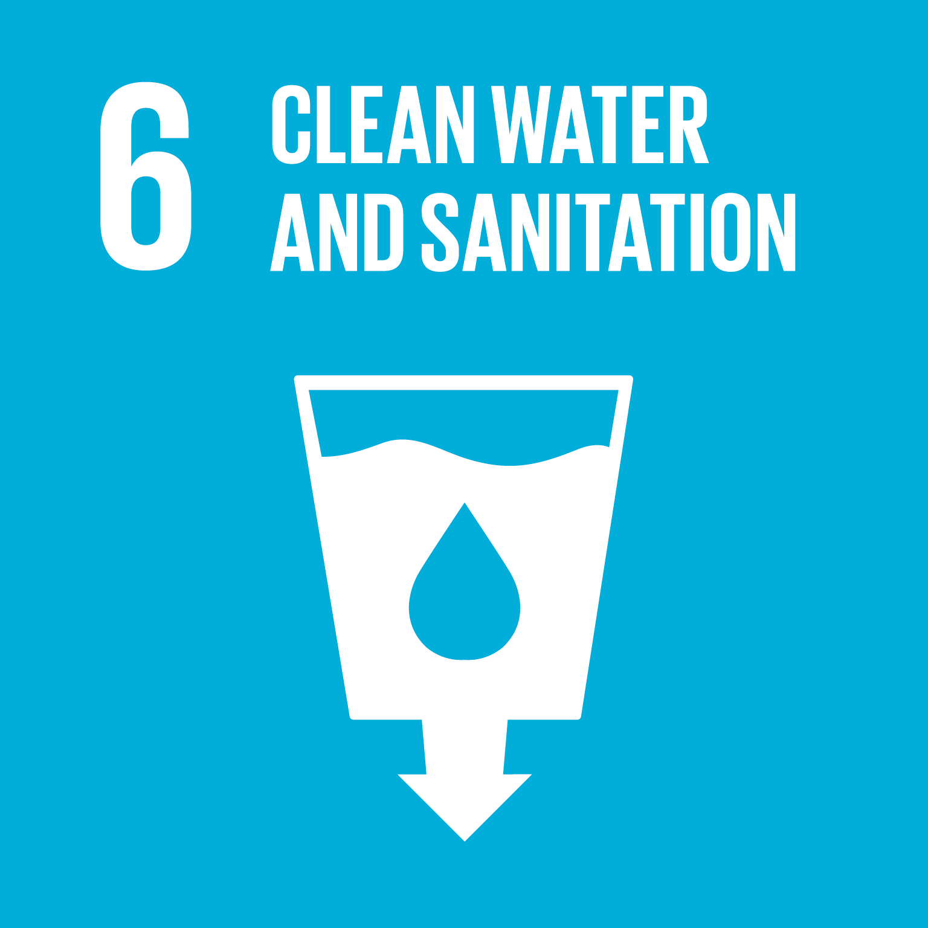OBJECTIVE OF SUSTAINABLE DEVELOPMENT 6 is to guarantee the availability and sustainable management of water and sanitation for all
achieve access to adequate and equitable sanitation and hygiene services for all and put an end to open defecation.
The water free of impurities and accessible to all is an essential part of the world in which we want to live. There is enough fresh water on the planet to achieve this dream. Shortages of water resources, poor water quality and inadequate sanitation have a negative impact on food security, livelihood options and educational opportunities for poor families around the world. Drought affects some of the poorest countries in the world, hunger and malnutrition intensify. By 2050, at least one in four people will probably live in a country affected by chronic and repeated shortages of fresh water.
Objective Goals 6. The SDG Fund brings together partners working on convergent aspects of water and sanitation: infrastructure, governance, health, education, environmental protection and gender equality. ... Guarantee healthy lives. Promote integrated water governance and adaptation to climate change.

Aruba is presented as an example in issues related to the supply and treatment of wastewater, since despite the rains are very scarce and that does not have any natural source of fresh water, it supplies 100% of the population with potable water. and electricity.
"Aruba is a pioneer in the process of desalination of water for human consumption in the Caribbean" the island's public water and energy company, W.E.B. Aruba N.V., responsible for the processes of purification and distribution through a modern desalination plant, is the second largest in the world for its size. Aruba has three modern wastewater treatment plants, which use advanced technologies such as tertiary filtration and UV disinfection, which allows a high rate of reuse of wastewater for irrigation and internal use of the plants.
the goal is to be the first fossil-free country by 2020 and to become one of the most sustainable islands in the Caribbean.

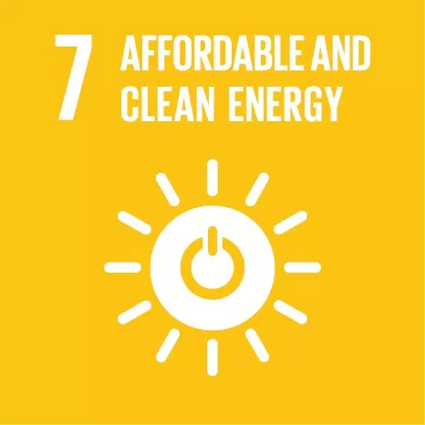SUSTAINABLE DEVELOPMENT OBJECTIVE 7
Ensure access to affordable, reliable, sustainable and modern energy for all
Sustainable energy is an opportunity - one that transforms lives, economies and the planet.
The growth of the world population, so will the demand for accessible energy. ... To guarantee universal access to affordable electricity by 2030, it is necessary to invest in clean energy sources, such as solar, wind and thermal.

